**Problem Statement 2: Shopping Cart for a Bookstore–Database schema design.**

**Create Database:**

mysql> create schema **shoppingcart**;

Query OK, 1 row affected (0.41 sec)

**Create table name as Books:**

mysql> create table Books(Book_Id int primary key, Book_Name varchar(255), Author varchar(255), Price int);

Query OK, 0 rows affected (1.08 sec)

**Create table name as order_details:**

mysql> create table Order_Details(Order_Id int primary key, Book_Id int, Cust_Name varchar(255), Phone_No int, Address varchar(255), Order_Date date, Quantity int);

Query OK, 0 rows affected (1.20 sec)

**Create table name as users:**

mysql> create table Users(first_name varchar(255) primary key, address varchar(255), email varchar(255), user_name varchar(255), password varchar(255), registration_date date);

Query OK, 0 rows affected (0.53 sec)

**ScreenShots:**

**Tables Created:**

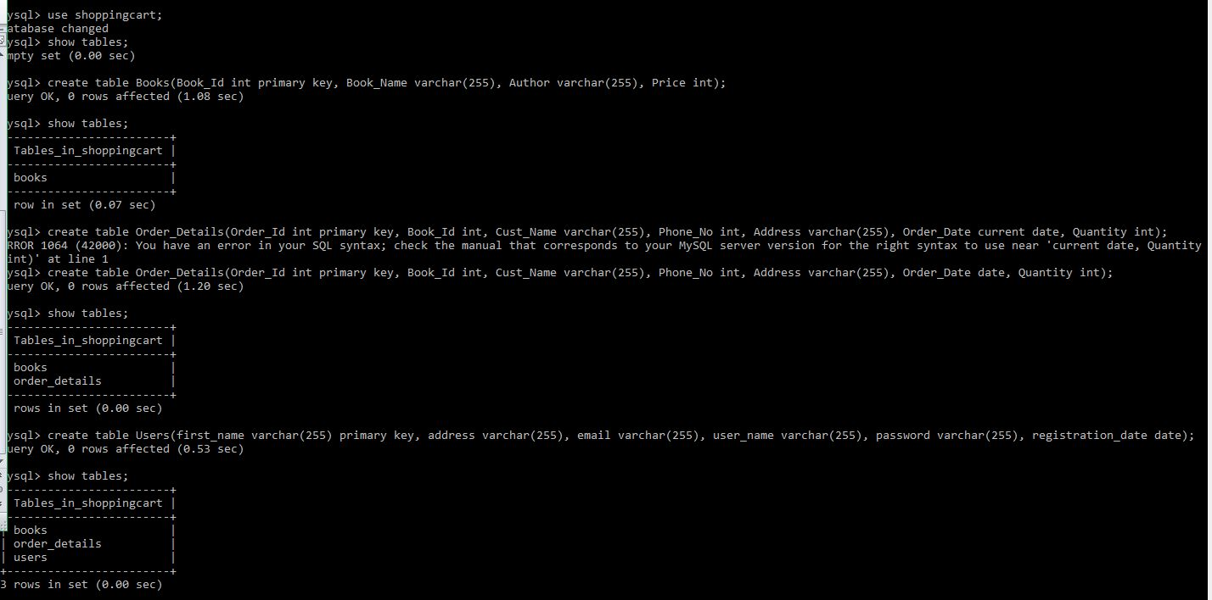

**Created Tables:**

